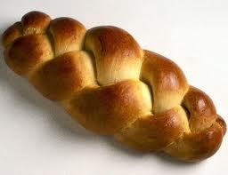
Plaited White Loaf
Ingredients
450g strong white bread flour
½ teaspoon salt
290ml milk
15g butter
1 teaspoon caster sugar
1 egg, beaten
Milk and sugar or poppy seeds to glaze
Method
Turn on oven to 200C
Sieve the flour and salt into the mixing bowl and make a well in the middle
Warm the milk and butter until the butter is melted and cool until tepid
Cream the yeast and sugar together
Mix the yeast, milk and egg together and pour into the well
Mix and knead on a floured surface until smooth and elastic (10 to 15 minutes)
Cover the bowl with cling film and put in a warm place to rise for about one hour. The dough should double in size
Divide into 3 equal pieces, form each piece into a long sausage and plait them together
Place on a greased and floured baking tray
Cover again with cling film and prove for 15 minutes
Brush with milk and sprinkle with sugar or poppy seeds
Bake for 25 minutes until golden and sounds hollow when tapped underneath
Equipment
Baking tray
Sieve
Bowl x3
Measuring jug
Knife
Scissors
Pastry brush
Today we are making BREAD COCKERELS in preparation for Easter
The bread dough is divided into 8 pieces and each piece formed into a cockerel before it is proved , glazed and baked
In parts of Holland on Palm Sunday children carry crosses decorated with a bread cockerel, palms and eggs to foretell the Easter story

